How to Create a Project Using Xcode & OpenCV

Download OpenCV - <http://opencv.org/releases.html>

Once downloaded link the ‘lib’ folder as a favourite.

Opencv-3.2.0 > build > lib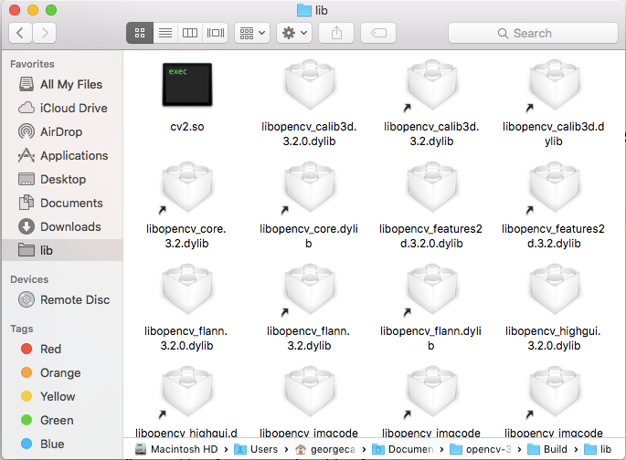

Open Xcode. File > New > Project > Command Line Tool > C++ format > Save.

Build Settings > Other Linker Flags > Paste the following;

-lopencv_calib3d -lopencv_core -lopencv_features2d -lopencv_flann -lopencv_highgui -lopencv_imgcodecs -lopencv_imgproc -lopencv_ml -lopencv_objdetect -lopencv_photo -lopencv_shape -lopencv_stitching -lopencv_superres -lopencv_ts -lopencv_video -lopencv_videoio -lopencv_videostab

Build Settings > Framework Search Paths > Paste the following;

/usr/local/lib

Build Settings > Header Search Paths > Paste the following;

/usr/local/include

Build Settings > Library Search Paths > Paste the following;

/Users/georgecarter/Documents/opencv-3.2.0/Build/lib